Junior International 2016
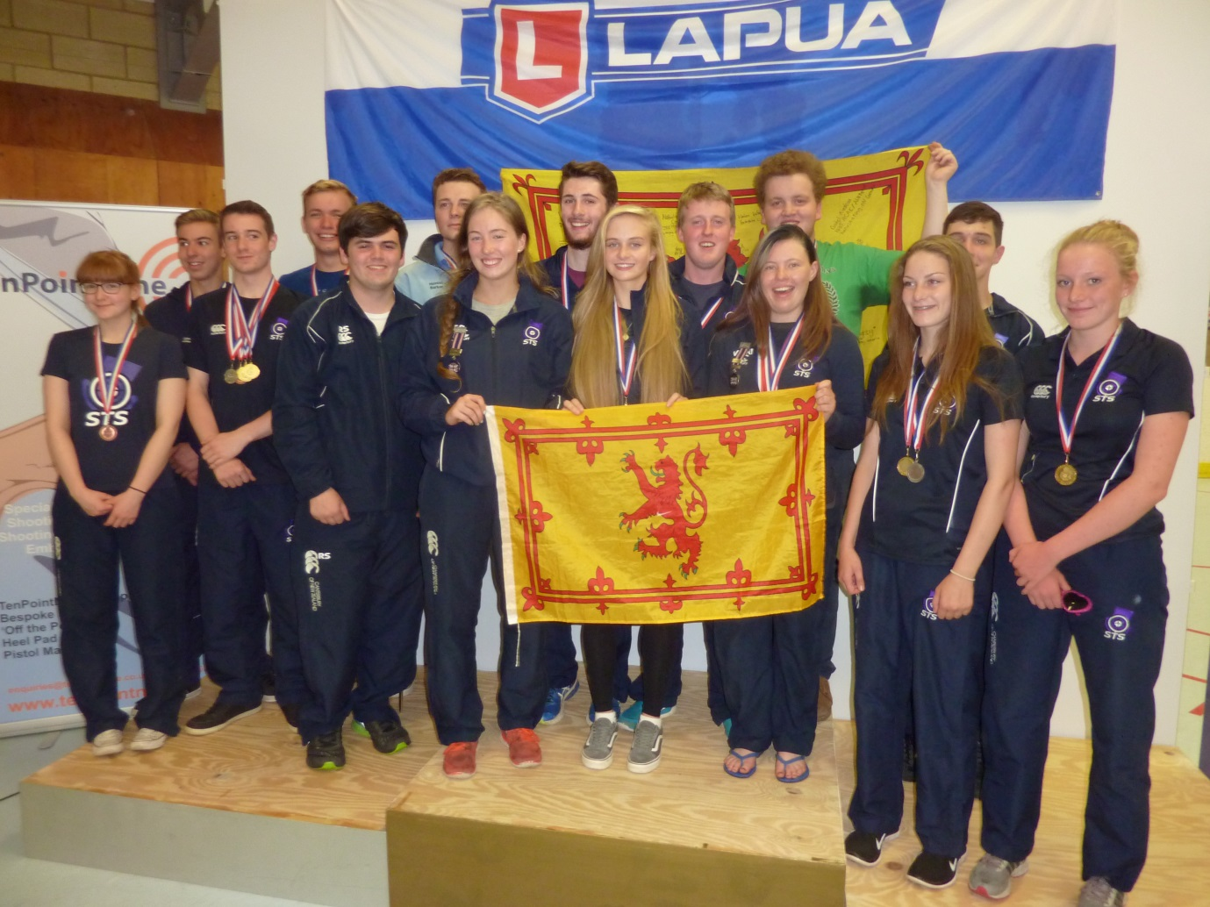

The combined Junior Rifle and Pistol Squads who achieved a record haul of 15 Medals at this year’s event. ( Rifle 5 / Pistol 10 )

The Rifle Squad showed a lot of enthusiasm for the Week and the biggest Team so far travelled to Bisley. Vikki Walls , Georgia Gooch , Brogan Smith , Steven Brown , Scott Norval , Tom Diggle , Daniel Gutteridge and Robin Shand made up the Squad.
The absence of the GB Junior Squad , due to re-structuring of the Squad , gave everyone else the opportunity to go for a medal. I’m not sure that any of the GB Squad would have matched the new Men’s Prone record of 620.4 set by Matthew Man from UK Scouts in very tricky conditions. Several of the former Squad represented their Region although they couldn’t represent GB.

On Mondays the 50M range is closed for maintenance , actually clearing up after a wedding , so we were restricted to Air Rifle training.
On Tuesday we had 50M training and the Air Rifle Grand Prix for Men and Women. In the Women’s event Vikki shot well to win the Bronze Medal and Georgia , with very little Air Rifle experience was 8th.
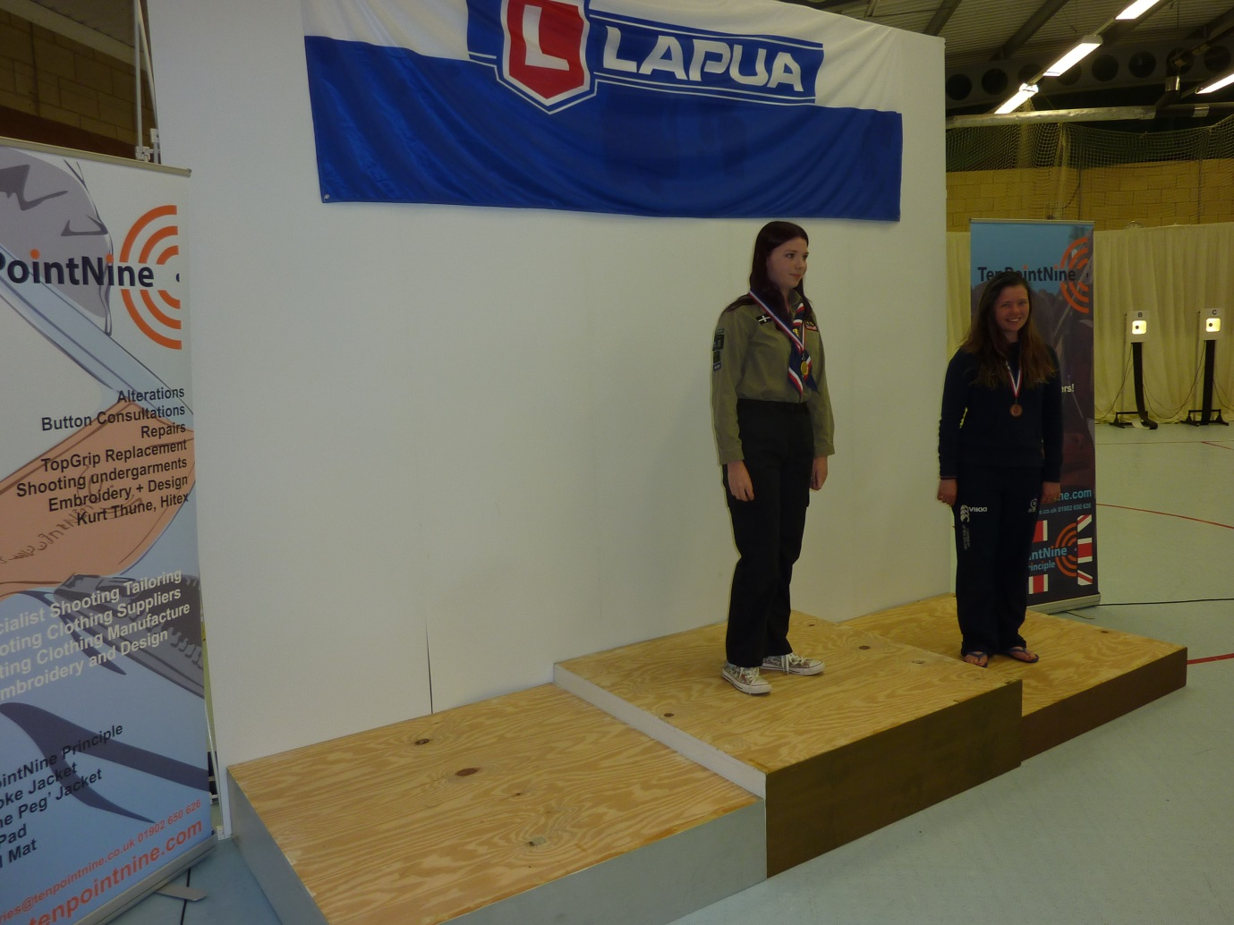

The Men did not perform quite so well with Brogan finishing in 5th place and Steven , with very little experience finishing 7th.
On Wednesday we had the 50M Prone Grand Prix for Men and Women. In the Women’s Grand Prix , Vikki finished in 3rd place behind competitors from Wales and Eastern Region and 0.6 ahead of Georgia.
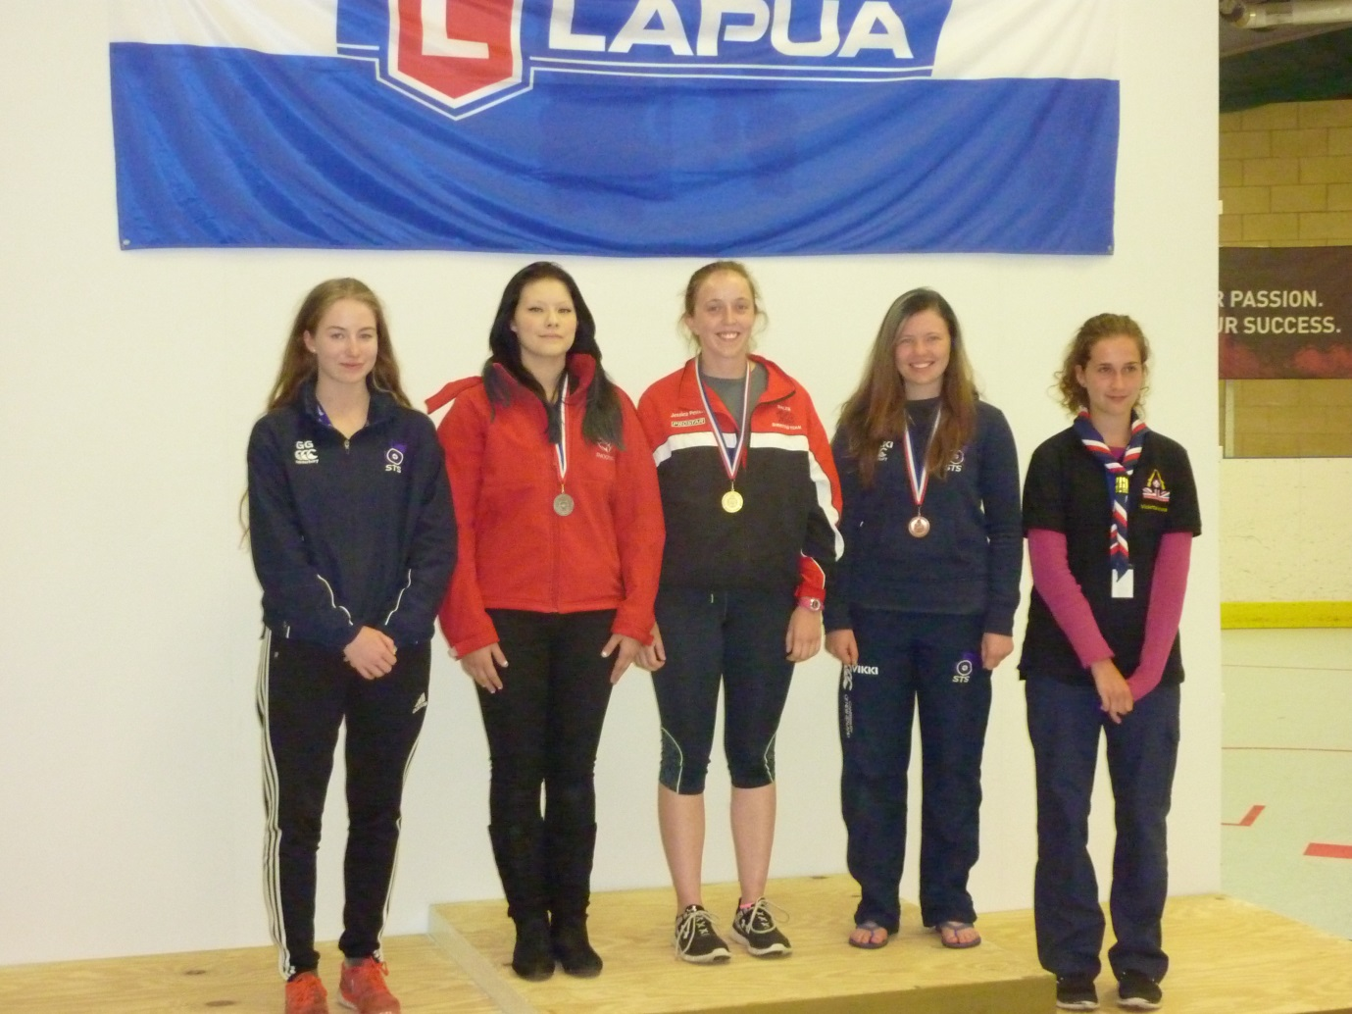

I’ll explain the group of 5 on the podium later. In the Men’s Grand Prix , Tom equalled Vikki’s performance by winning the Bronze Medal with a score of 603.2 which was the only score from the boys to beat the girl’s scores during the week. Tom was beaten by competitors from UK Scouts and Wales. The 6 Men in the Squad finished from 3rd to 11th position which was very consistent.
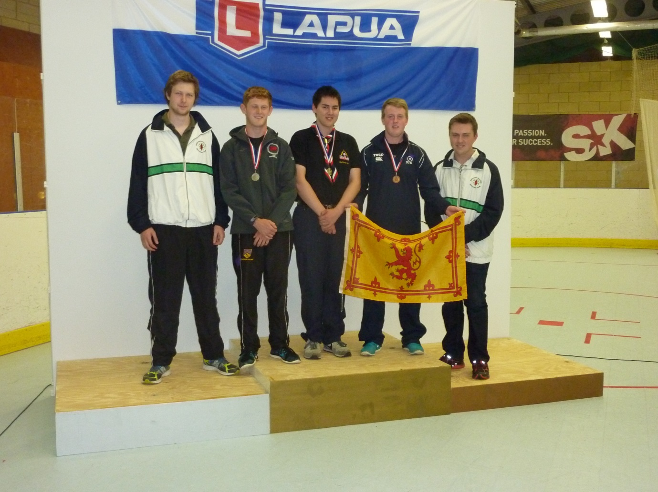

The reason for additional competitors on the podium is that the GB Junior Team for the Drew Match against the USA , Australia and New Zealand was selected from the Grand Prix Matches. Previously the Team was selected at random during the first weekend of the British Championships. We always had problems finding a Team and the Juniors were always tired after competing all day in the Championships. The decision was to shoot the match concurrent with the Main matches the following day. The Team of 5 boys and 5 girls included Tom , Georgia and Vikki. They were the top 10 on the day.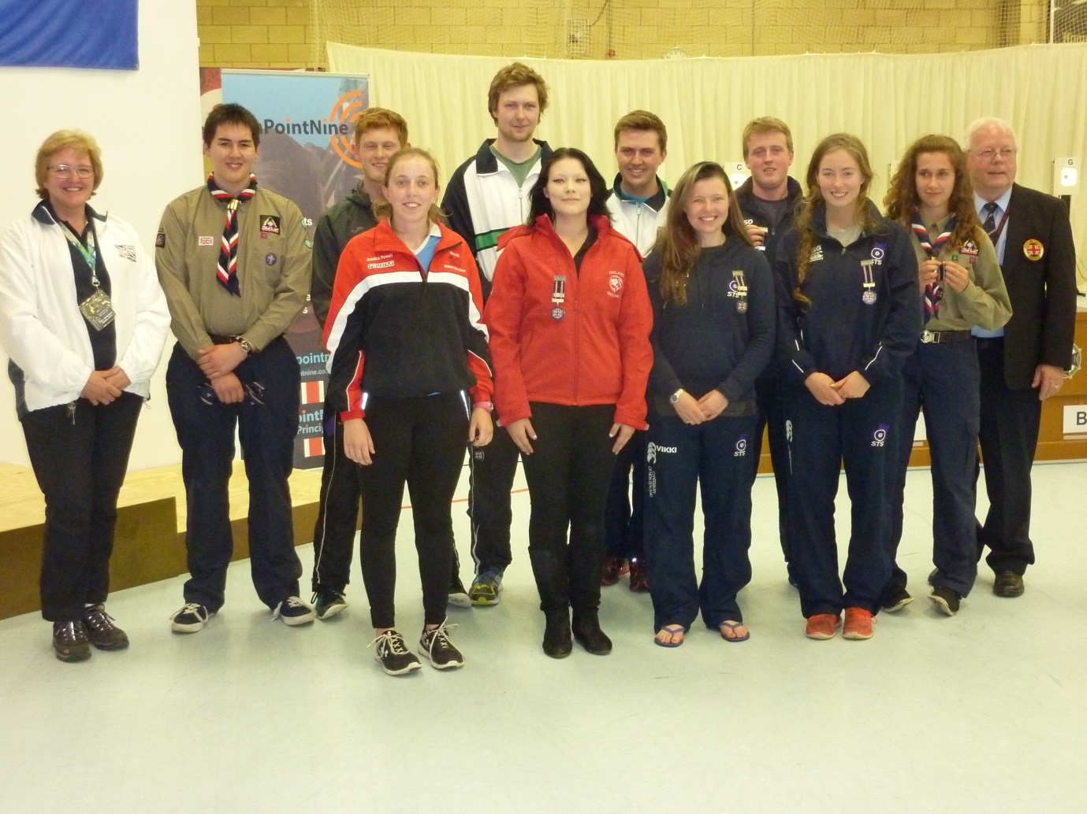
The change proved to be successful with Team shooting the best score in many years.
The Thursday programme includes the Main Air Rifle Match , The Main Prone Match and the Finals so it can be a very demanding day. In the Women’s Air Rifle Vikki was again successful , winning the Silver Medal this time. The winner from South Africa started with a good lead of 2.5 points going in to the knock out section but Vikki closed that to 0.2 on the last shot so a good final. Georgia finished in 9th place.
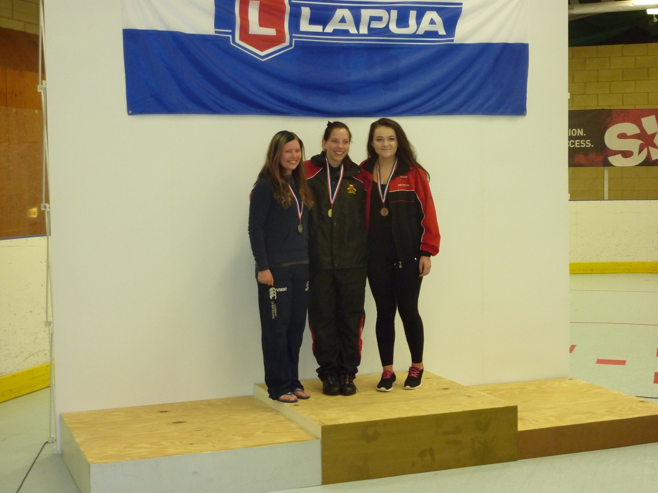
The Men were less successful again with Brogan finishing in 6th place and Steven in 8th place.
On the 50M range on Wednesday I would describe conditions as tricky. On the Thursday I would say horrific with flags 1.5M apart blowing in opposite directions. I was relieved that I was not shooting. The scores were , therefore , lower than the previous day. In the Men and Women’s Prone event we didn’t win any Individual Medals but had some good performances. Georgia shot the best score to finish 6th , with Vikki 9th in the Women’s event. In the Men’s prone event Scott qualified in 7th place and finished 6th while Daniel qualified in 8th place and finished 5th. Great experience for both competitors in their first final.
For the Men’s Prone Team I had the A Team in my mind a couple of weeks before the Match but set a challenge that I would select the Team based on the Grand Prix results so not the Team I had in mind. I then set a challenge for the B Team to beat the A Team and that’s exactly what they did , winning the Bronze Medal.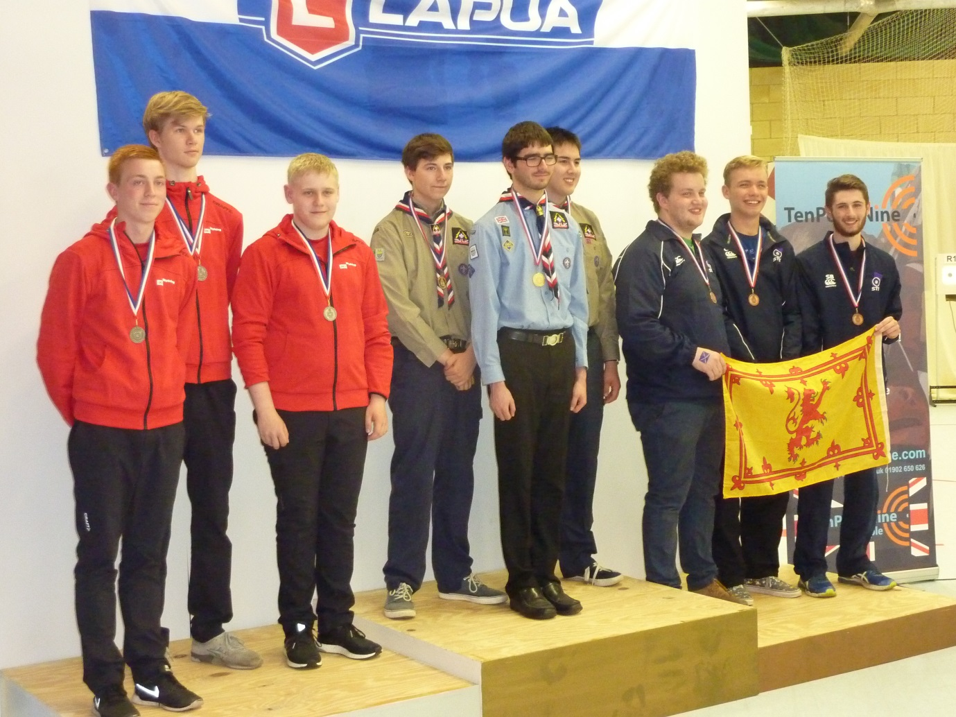
The winning Team were UK Scouts , who have several talented shooters , with Denmark in second place.
On the first weekend of the British Championships there is an annual match of the GB Schools against the Danish Schools. Most of the Squad stayed for the weekend so were available for the match. The Danish Team had 3 boys and 3 girls who had finished second and first in the Team events during the JI Week so it was going to be a tough match. Georgia and Scott were selected for the Team of 6 who successfully beat the Danish Team by a small margin.
The week provided excellent experience for the Squad and the enthusiasm of both the Rifle and Pistol Squads was wonderful.

Ian Thomson

